# Objectives:

The objectives for this report are to respond to Relax’s request for a brief one-page writeup of findings that includes summary tables, graphs, etc... to explain the approach, notation of factors considered or investigation completed. Close with any further research or data ideas

# Exploratory Data Analysis

## Findings:

1. Out of 12,000 users, 1656 (14%) are adopted
2. The “Organization” option is the most popular creation source, indicating that the majority of Relax customers are businesses.

|  |  |  |
| --- | --- | --- |
|  |  |  |

1. 54% of all users were brought on by another user, while 57% of adopted users were brought on by another user.
2. The only two variables with correlation are “on mailing list” and “on marketing drip”; which have approxmately a 50% correlation.

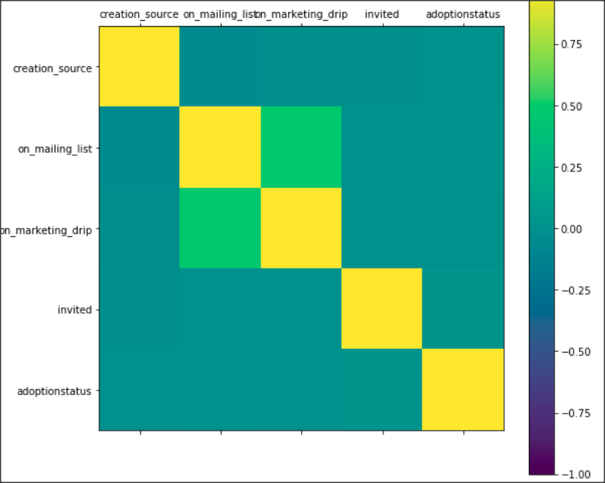

## Recommended Next Steps:

1. It does not appear that any of the features are by themselves a strong predictor of adoption, so machine learning may want to focus on ensemble algorithms, such as RandomForest.
2. Not surprisingly, most customerss are using this software for their organization (usually equates to the place of employment). It would be interesting to add additional information, such as organization size to see if there is a trend towards larger or smaller organizations for both number of customers and number of customers that are adopted.

[link to folder containing notebook](https://github.com/krpopkin/CapstoneProject2Repository/tree/master/02%20Milestone%20Report%201)